DEVOPS/AWS
Name: P MANJUNATHA REDDY 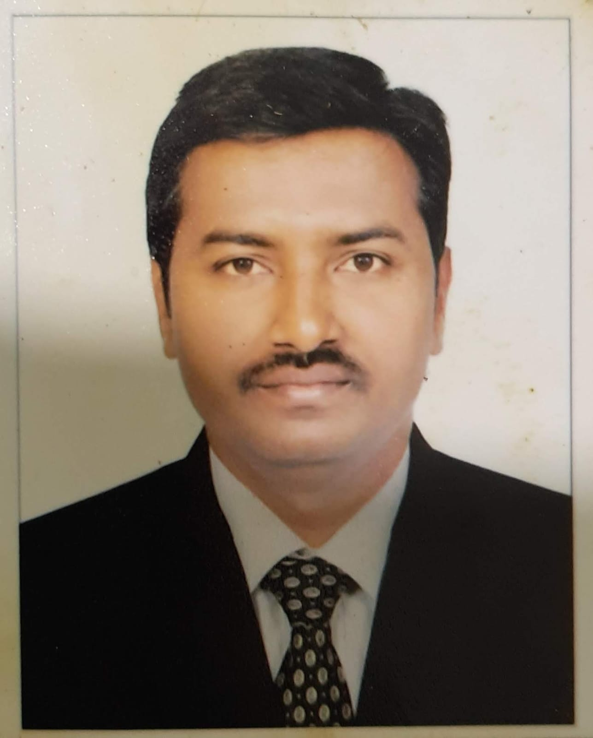
Email: pmreddy87@gmail.com
Phone: (M) +91 9890104957
Having around 3.5 Years of professional experience in build and release and software configuration management which includes Environment Setup, Build Automation, and Continuous Integration and continues Deployment CI/CD, cloud AWS, SCM process improvements and Deployments Web applications.

Professional Summary

- Having around 3.5 Years of Experience as a “DevOps/Build & Release Engineer” for Java Based Web Applications.
- Implemented Infrastructure automation through Ansible for auto provisioning, code deployments, software installation and configuration updates.
- Experience with container-based deployments using Docker, working with Docker images, Docker Hub and Docker-registries and Kubernetes.
- Building/Maintaining Docker container clusters managed by Kubernetes, Linux, GIT, Docker on AWS. Utilized Kubernetes and Docker for the runtime environment of the CI/CD system to build, tests deploy.
- Having Experience in implementation of CI/CD.
- Working experience in writing the Ansible playbooks for creating AWS services like VPC,EC2,S3, Autoscaling, ELB etc.
- Configuring the Docker containers and creating Docker files for different environments.
- Good knowledge in creating the Docker Images and configuring the images in Jenkins.
- Working experience in Stage, UAT and Production environment using ANSIBLE.
- Worked in JIRAautomation in Jenkins build and deployment process.
- Installed number ofplugins in Jenkins for project requirement.
- Configured Build Machines or Nodes in Jenkins.
- Good experience in automating the process of uploading the packages from Jenkins using backup repository Jfrog.
- Responsible for administering and supporting version control systems (GIT) on Linux.
- Experience in Creating branches, tags, user locking, branch locking, and Daily Activities Included Force builds, daily patches in GIT.
- Expert in build automation tool MAVEN for Build development in Windows and Linux.
- Extensive experience using MAVEN as build tool for the building of deployable artefacts from source code.
- Experience in Build & Release Activities, which involves Building source code, handling and Administration of Version control tools (Git), maintaining CI environments (Jenkins).
- Build, Configure, Manage and Coordinate all Build and Release Management activities.
- Expertise in Installation, Configuration, Administration and Maintenance of CI tools Jenkins.
- Experience with Application servers configuration and management.
- Install/Configure build, package and deliver java application to Application server.
- Responsible for the development of tools, scripts, installation procedures and systems including source code control and issue tracking.
- Ability to troubleshoot build and deployment issues.
- Capable of working independently and as well as a part of a team.
- Good work experience in end-to-end Building, deploying and configuration process and Implementation from local QA environment to UAT and Production.
- Taking care builds and deployments in local, staging and production environments.
- Experience in supporting applications on different platforms Windows and Linux environments.

Professional Experience

IT- Experience

Project: Data communications company
Technology : Linux, Git, Jenkins, Maven, Docker, Ansible, AWS
Application sever: Apache Tomcat
Duration: Feb 2019 to till date
Organisation: Golden source software solutions
Designation: Build and release engineer

Non- IT experience

- Worked as Asst. Construction manager in Larsen and Tourbro Limited (L&T), Kochi metro rail project from Feb’ 2012 to Mar’ 2016
- Worked as Engineer Civil in Credible engineering construction, Leh-ladakh road project from Apr’ 2010 to Feb’ 2012
- Worked as Junior engineer planning in Meenakshi infrastructure pvt Limited, Bhadrak-balasore road project - Orissa from May’ 2009 to Mar’ 2010

Education:

Course | Institution | BOARD/  UNIVERSITY | Year of passing | Percentage
B.Tech  (Civil engineering) | G. Pulla Reddy Engineering College, Kurnool, Andhra Pradesh | Sri Krishnadevaraya University, Anantapur, Andhra Pradesh | April’  2009 | 61.5
Intermediate MPC | Crescent Junior college | Board of Intermediate | April’ 2005 | 80.9
SSC | Govt. High school, Kanekal | Secondary school education | April’ 2003 | 76.5

Technical Proficiency

Scripting language | Shell scripting
Development Environment | Linux
Orchestration Tool | Kubernetes
Build Tool | Maven
Continuous Integration | Jenkins
Deployment Tools | Ansible
Containerization Tool | Docker
Cloud Environment | Amazon Web Service(EC2, S3, CloudWatch, ELB, IAM,RDS, AMI)
Version Control System Tools | GIT
Operating Systems | Linux, Ubuntu, RedHat

Personal Information:

Name: P Manjunatha reddy
Father’s name: P Somasekhar reddy
Permanent address: H. no 1/36, yerragunata (P), Kanekal (M), Ananthapuramu (Dist), Andhra Pradesh -515871
Residential address: H.no 139, Sree akshay nilaya, Sorahunse, Varthur - 560087
Marital status: Married
Birthday: 01/07/1987
Nationality: Indian
Gender: Male

Declaration:

I do hereby declare that above particulars of information and facts stated are true, correct and complete to the best of my knowledge and belief.

P Manjunatha reddy

